Answer. 1 statistics

SAT scores and college GPA are has positive correlation

Answer. 2 statistics

1. 68% (explanation-160-180 is come in 1 sigma range on each side from mean)
2. 30% [z score=(x-mu)/(sigma)]

x=175

mu=170

sigma=10

Poulation standard deviation given so choose Z-score

Z=(x-mu)/(sigma)

Z=0.5

At Z=0.5 in Z-table

Probability=0.3085=30%

1. Z=1.5

x=185

mu=170

sigma=10

# Poulation standard deviation given so choose Z-score

Z=(x-mu)/(sigma)

d. 153.6 cm

x=170

Lower CI= x-Z0.5*sigma

Lower CI = 170-1.64*10

=153.6 cm

e. 0.058

CV=sigma/mu

CV= 10/170

= 0.058

Answer. 3 statistics -> <https://github.com/Lokeshrajkp/Placement-Assignment_Lokeshraj-K-P/blob/main/Statistics/statistics_answer_3.ipynb>

Answer. 4 statistics

Probability=0.2

Total outcome=20

Favourable outcome=4

Probability=4/20=0.2

20%

Answer. 5 statistics

Probability that it belongs to Company A is 0.66 or 66%

Company A's success rate 95%

Company B's success rate 90%

Company A taxis=80%

Company B taxi=20%

According to Bayes theorem,

P(A|B)=(P(B|A)*P(A))/P(B)

P(A)=0.8

P(B|A)=1-0.95=0.05

P(B)=0.2

P(B|B) = 1 - 0.90 = 0.10

P(B) = P(B|A) * P(A) + P(B|B) * P(B)

P(B) = 0.05 * 0.80 + 0.10 * 0.20

P(B)=0.06

Now substitute in Bayes theroem

P(A|B)=(0.05 * 0.80) / 0.06

P(A|B)=0.66

= 66%

Answer. 6 statistics -> <https://github.com/Lokeshrajkp/Placement-Assignment_Lokeshraj-K-P/blob/main/Statistics/statistics_answer_6.ipynb>

Answer. 7 statistics

2𝑋 + 3 − 8 = 0 & 2𝑌 + 𝑋 − 5 = 0

2𝑋 + 3 − 8 = 0

2𝑋 − 5 = 0

2𝑋 = 5

𝑋 = 5/2

2𝑌 + 𝑋 − 5 = 0

2𝑌 + (5/2) − 5 = 0

2𝑌 − 5/2 = 0

2𝑌 = 5/2

𝑌 = 5/4

a. Variance of Y= 4

Var(𝑌) = Var(𝑋) × (1 - R²)

Var(𝑋) = 4

2𝑌 + 𝑋 − 5 = 0

2𝑌 + (5/2) − 5 = 0

2𝑌 = 5/2 - 5/2

2𝑌 = 0

𝑌 = 0/2

𝑌 = 0

𝑌 is constant and doesn't depend on 𝑋. Hence, R² =0

Var(𝑌) = 4 × (1 - R²)

Var(𝑌) = 4 × (1 - 0)

Var(𝑌) = 4 × 1

**Var(𝑌) = 4**

b. Coefficient of determination of C and Y= 0

Coefficient of determination (R²)=0

c. Standard error of estimate of X on Y and of Y on X.

Standard error of estimate of X on Y=2

Standard error of estimate of Y on X=2

SE(estimate) = sqrt((Var(𝑌) × (1 - R²)))

Standard error of estimate of X on Y= sqrt(4*(1-0))= 2

SE(estimate) = sqrt((Var(X) × (1 - R²)))

Standard error of estimate of Y on X= sqrt(4*(1-0))= 2

Answer. 9 statistics -> <https://raw.githubusercontent.com/Lokeshrajkp/Placement-Assignment_Lokeshraj-K-P/main/Statistics/statistics_9.ipynb>

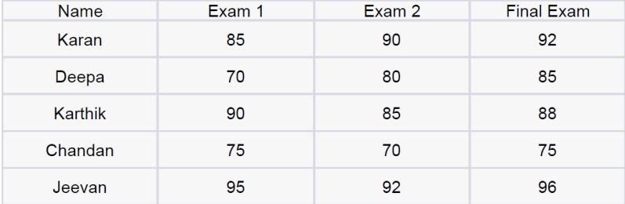

Mean 83 83.4 87.2

Null hypothesis:

H0:μ1=μ2=μ3

Means are equal

Alternate hypothesis:

H1: μ1≠μ2≠μ3

Means are not equal

Total mean=( 83+83.4+87.7)/3=84.5

n1=n2=n3=5

k=3

SSB = 6(5 - 8)2 + 6(9 - 8)2 + 6(10 - 8)2

SSB=53.72

df1 = k - 1 = 2

SSE = 430+311.2+254.8=996

N = 15

df2 = N - k = 15 - 3 = 12

MSB = SSB / df1 = 53.72 / 2 = 26.86

MSE = SSE / df2 = 996 / 12 = 83

ANOVA test statistic, f = MSB / MSE = 26.86 /83 = 0.323

Using the f table at α= 0.05 the critical value is given as F(0.05,2,12)=3.88

As f < F, thus, the null hypothesis is accepted and it can be concluded that there is no difference in the mean.

**Answer:** Fail to reject the null hypothesis

Answer. 10 statistics -><https://raw.githubusercontent.com/Lokeshrajkp/Placement-Assignment_Lokeshraj-K-P/main/Statistics/Statistics_10.ipynb>

Number of trials (n) = 500 (batch of light bulbs)

Probability of success (p) = 0.05 (probability of a bulb being defective)

Probability of failure (q) = 1 - p = 0.95 (probability of a bulb not being defective)

a. What is the probability that exactly 20 bulbs are defective?

P(X = 20) = (500C20) * (0.05)^20 * (0.95)^(500 - 20)

P(X = 20) =0.05162

b. What is the probability that at least 10 bulbs are defective?

P(X ≥ 10) = P(X = 10) + P(X = 11) + ... + P(X = 500)

P(X ≥ 10)=0.99983

c. What is the probability that at max 15 bulbs are defective?

P(X ≤ 15) = P(X = 0) + P(X = 1) + ... + P(X = 15)

P(X ≤ 15)=0.01986

d. On average, how many defective bulbs would you expect in a batch of 500?

E(X) = n * p =500*0.05

E(X)=25 bulb

Answer. 12 statistics ->

<https://raw.githubusercontent.com/Lokeshrajkp/Placement-Assignment_Lokeshraj-K-P/main/Statistics/statistics_12.ipynb>

a.

Null hypothesis (H₀): There is no significant difference in the mean improvement scores between Group A and Group B.

Alternative hypothesis (H₁): There is a significant difference in the mean improvement scores between Group A and Group B.

mean of Group A ==2.5

mean of Group B = =2.2

standard deviation of Group A = S1=0.8

standard deviation of Group B =S2=0.6

sample size of Group A =n1= 30

sample size of Group B ==n2= 30

Pooled standard deviation formula

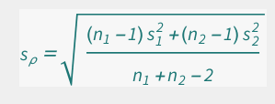

sp=sqrt(((30-1)*(0.8)**2+(30-1)*(0.6)**2)/(30+30-2))

sp=0.707

t-static

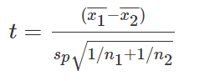

t=(2.5-2.2)/(0.707*sqrt(1/30+1/30))

t=1.643

DOF=30+30-2

DOF=58

The *t* value with α = 0.05 and 58 degrees of freedom is 2.001

Since 1.64<2.001 , the t-statistic does not exceed the critical value

b. Since t-static(1.64)< critical value(2.001) we failed to reject null hypothesis